Annexure-V- Cover Page for Academic Tasks

Course Code: MGNM511 Course Title: MARKETING MANAGEMENT-II
Course Instructor: Rajesh Dorbala Academic Task No.: 02
Academic Task Title: Assignment 02 Date of submission: 18th Dec, 2022
Student Name: Nowneesh T Section: Q2240
Student’s Roll No: RQ2240A19 Student’s Reg. No: 12202342

Evaluation Parameters: (Parameters on which student is to be evaluated- To be mentioned by students as specified at the time of assigning the task by the instructor)

Learning Outcomes: (Student to write briefly about learnings obtained from the academic tasks)

Declaration:

I declare that this Assignment is my individual work. I have not copied it from any other student’s work or from any other source except where due acknowledgement is made explicitly in the text, nor has any part been written for me by any other person.

Student’s Signature: Nowneesh T(18CSR124)

Evaluator’s comments (For Instructor’s use only)

General Observations Suggestions for Improvement Best part of assignment

Evaluator’s Signature and Date:

Marks Obtained:
Max. Marks:

LOVELY PROFESSIONAL UNIVERSITY

Academic Task Number: 2
Individual Assignment
MITTAL SCHOOL OF BUSINESS DEPARTMENT OF MARKETING
Faculty Member: Rajesh Dorbala Section: Q2239/Q2240
Course code: MKTM511 Course title: Marketing Management-II
Academic Task Type: Online Assignment Maximum Marks: 30
Date of allotment: 09 Dec, 2022 Date of submission: 18 Dec, 2022
Important Notes:
1. No late submission will be accepted.
2. Students should write their own analysis. In case any two or more submissions are found to be having the copied content then no marks will be awarded to those students.
3. There should not be any plagiarism in the submission. Proper reference should be given for the data taken from any online source.
Detail of Academic Task | Course Outcome | Bloom’s level
Students in already defined groups in academic task 1 will attempt this assignment. Considering the already selected company and its specific product/service and explore the following:  - Based on the customer profiling already created, specify a set of your target audience, and clearly detail about the one (most important as per you) social media platform that you will use to communicate your message and which targeting strategy you will use primarily?  Refer to annexure 1 for reference  Max Marks – 10  - For the selected product/service, identify 5 most important keywords that the company should focus on for the purpose of On-Page SEO. You will have to clearly specify where these keywords should be used by the company on the web page i.e., XYZ keyword should be put in the Title tag or ABC keyword should be put in Meta tag or Header or in ALT-Text of an image on the page.  Refer to the temple given in annexure 2 for a specific format to attempt this part.  Max Marks – 10  - For your identified company, for the social media platform that you have identified in point 1, perform a social media audit and compare its performance with the biggest competitor (as identified by you) on the similar social media platform.  Max Marks - 10  As a group, submit a presentation in no more than 4 slides (excluding the title slide)  Note: Peer rating is applicable with minimum difference of 1 mark and should be given on the title slide only. In case peer rating is not provided in the submission, the respective faculty will decide the peer rating of his/her own. | CO3, CO4, CO5 | L3: Apply  L4: Analyze  L6: Create
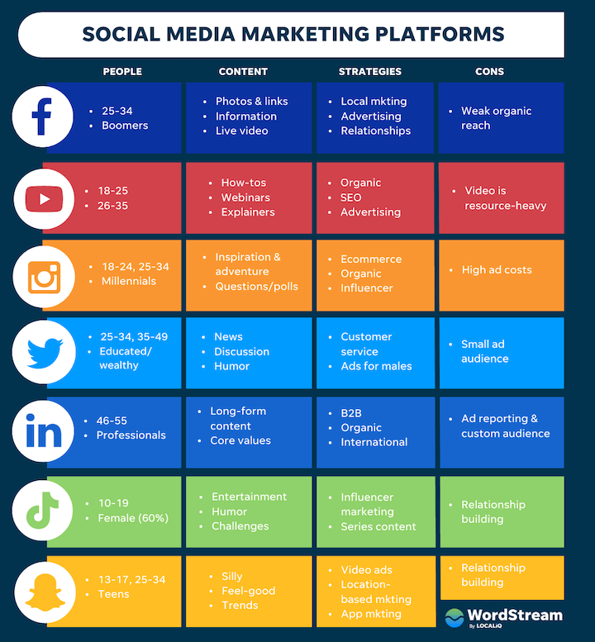
Annexure 1

Annexure 2-
Specify the keywords identified :
S No | Identified Keyword | Why this is important to be used as keyword? | Reason for selection and choice of location on page (like Title Tag, header or content etc)
1
2
3
4
5

